**Fundamental of vehicle dynamics**

A knowledge of the forces and moments generated by wheels is essential to understanding vehicle dynamics.

The subject of vehicle dynamics is concern with the movements of vehicles – automobiles, trucks, buses, and special-purpose vehicles – on a road surface. The movements of interest are acceleration, riding, braking and turning. Dynamic behavior is determined by the forces imposed on the vehicle from the wheels, gravity, and aerodynamics. The vehicles and ít components are studied to determine what force wll be produced by each of these source and how the vehicle will respond to these force. Since our car doesnot have a brake system, in this thesis we only investigate the vehicle dynamics in accerelation and turning.

**1. Tires Modeling**

**Slip**

In order to generate forces while rolling, the tire must slip. Slip occurs in different planes of the tire’s motion. Longitudinal slip will be considered first.

Effective Rolling Radius

When the tire is rolling freely (no driving or braking force applied), the effective rolling radius Re may be defined as follows:

$$R_{e}=\frac{v_{x}}{ω}$$

where vx is the longitudinal velocity of the wheel centre, and ω is the wheel’s angular velocity.

**Longitudinal Slip**

When a driving or braking torque is applied to the wheel, longitudinal slip develops. The slip velocity is the relative velocity of the tire contact patch with the ground, and is given by vx − vc where vc = Reω is the circumferential velocity of the tire. The slip is obtained  
by normalizing the slip velocity. Two definitions of longitudinal slip are commonly used. The first, denoted λ, is normalized by the longitudinal velocity vx:

$$λ=-\frac{v_{x}-R_{e}ω}{v_{x}}$$

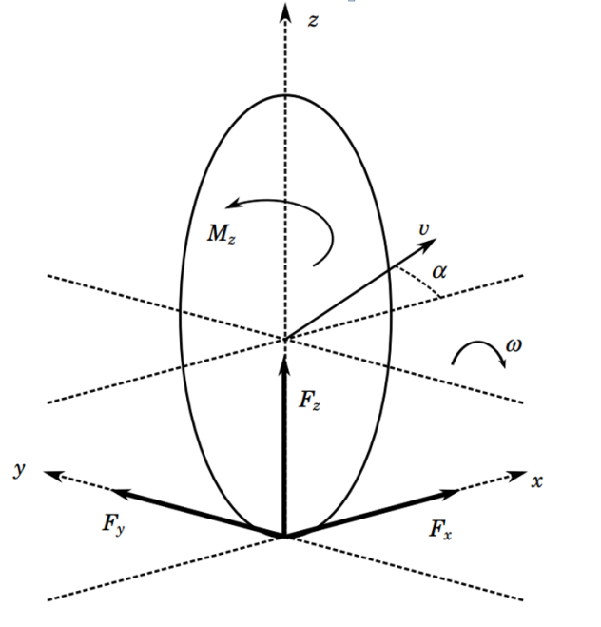

**Derivation of Tire Forces**  
In the derivation of the model it will be convenient to express the tireforces acting on the vehicle as resultant forces in the x and y directions of the Sv frame as well as a resultant moment about the z axis. These forces and moments will be referred to as generalized forces. By considering figure 2

the following expressions relating the individual tire forces to the generalized forces are obtained:

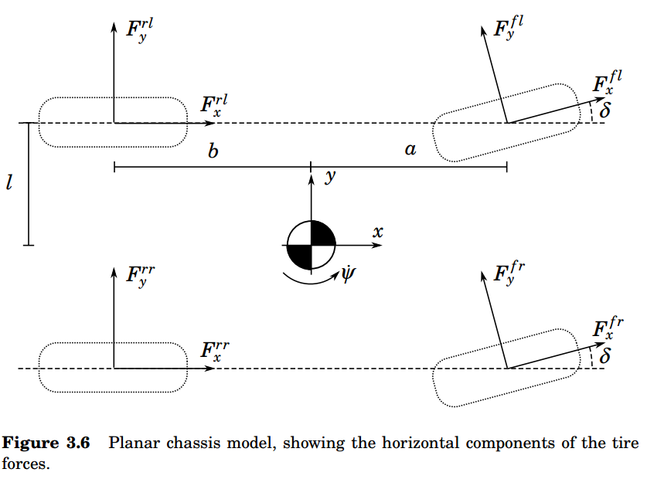

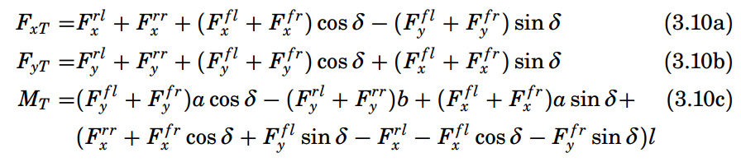

**Angular Motion**

Euler’s equation states that the sum of the external torque acting on a system is given by the rate of change of angular momentum:

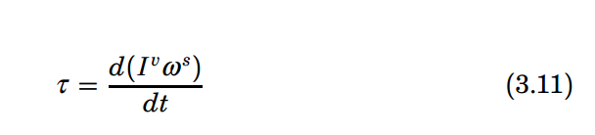

τ is the external torque or moment applied to the system, Iv is the inertia tensor relative to the coordinate frame in which the equations are to be derived, and ωs is the spacial angular velocity.

**Models for Control Design**

A linear model including roll dynamics could be used for roll control, and linear models are indeed extensively used in the literature. However, linear models use a number of assumptions and approximations which are unlikely to be valid during extreme maneuvering. These include:  
• Constant longitudinal velocity  
• Small steering angles  
• Linear tire forces  
• Simple approximations of tire slip values (α)  
These approximations imply that although linear models may be useful for designing control systems intended for use under ‘normal’ driving conditions, they may be of limited use for the case of extreme maneuvering, where nonlinearities in tire characteristics and vehicle dynamics must be taken into account. In addition, the load transfer which occurs during  
extreme maneuvering cannot be modeled with a single-track model.

**4.1 Static Rollover Analysis**

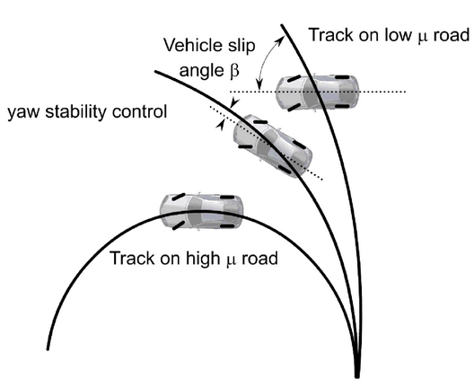

The underlying cause of untripped vehicle rollover accidents is the rotational motion occurring when a vehicle makes a turn.

The external forces acting on the vehicle act at the road-tire contact point, not the centre of gravity, meaning that a resulting moment acts on the vehicle. The magnitude of the resulting moment depends on the height of the centre of gravity above the road. A higher centre of gravity gives a larger moment. This moment is counteracted by a moment due to the reaction (normal) forces acting on the tires on the outside of the turn. This moment depends on the track width of the vehicle (the distance between inner and outer wheels). Clearly, if the moment due to the rotational motion of the vehicle exceeds the moment due to the the normal forces on the tires, then the vehicle will begin to roll. A static condition for rollover can be derived from consideration of the resultant force vector acting on the center of gravity. If the line of action of the force lies outside the contact point of the outside wheels, then rollover will occur.

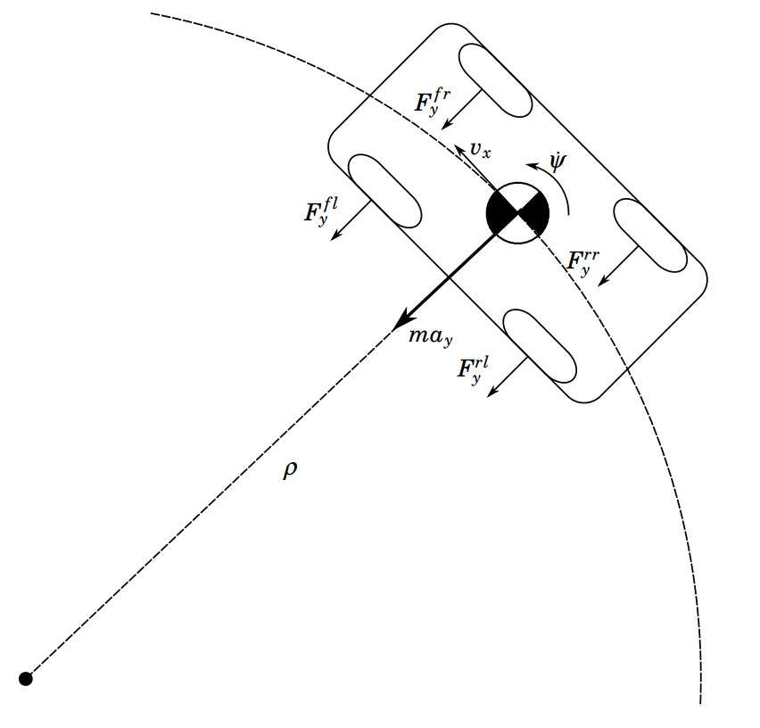

Figure 4.3 illustrates the situation in the case of a vehicle without suspension. In this case, the condition for rollover to occur is:

